# Department of Computing

# Class: SE-7B

# Lab 5: Functions

# Date: October 26, 2016

# Time: 2pm-5pm

# Instructor: Dr. Muddasir

# Lab 5: If/elif statements

**Tools/Software Requirement**

Python

#### Lab Tasks:

Take two inputs from user and print them in same line alternatively thrice.

1. Assume that a video store employee is paid PKR 20000 for the first 40 hours, time-and-a-half (1.5 times the regular pay rate) for the first five hours over 40, and double-time pay for all hours over 45. Assuming a 28 percent tax rate, write a program that prints his gross pay, taxes, and net pay to the screen. Label each amount with appropriate titles (using string literals) and add appropriate comments in the program. Employee must work 40 hours each week.
2. Write a program that could be used by a video store to calculate a discount, based on customer status. Customers are classified either R for Regular or S for Special. Special customers have been members of the rental club for more than one year. They automatically receive a 50-cent discount on all rentals. The store also holds “value days” several times a year. On value days, all customers receive the 50-cent discount. Special customers do not receive an additional 50 cents off during value days, because every day is a discount for them. Each video costs 1.5$.  
     
   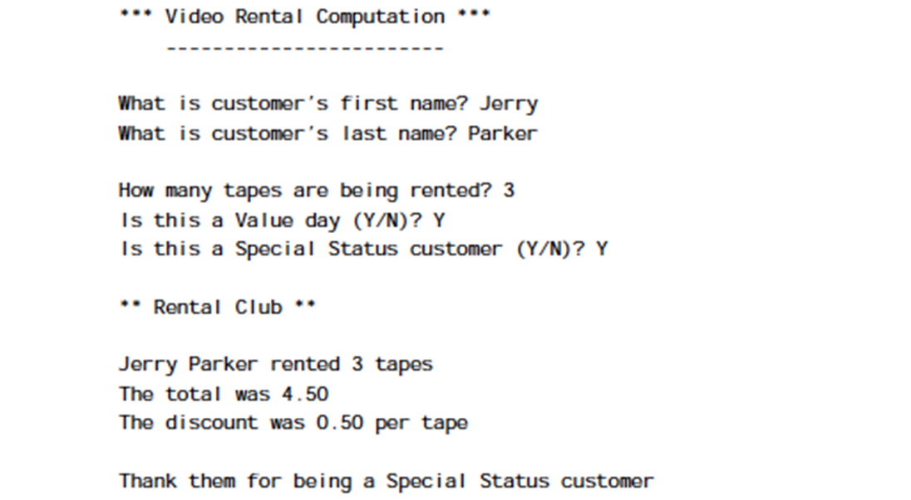
3. A library charges a fine for every book returned late. For first 5 days the fine is 50 paise, for 6-10 days fine is one rupee and above 10 days fine is 5 rupees. If you return the book after 30 days your membership will be cancelled. Write a program to accept the number of days the member is late to return the book and display the fine or the appropriate message.
4. An Insurance company follows following rules to calculate premium.
   * If a person’s health is excellent and the person is between 25 and 35 years of age and lives in a city and is a male then the premium is Rs. 4 per thousand and his policy amount cannot exceed Rs. 2 lakhs.
   * If a person satisfies all the above conditions except that the sex is female then the premium is Rs. 3 per thousand and her policy amount cannot exceed Rs. 1 lakh.
   * If a person’s health is poor and the person is between 25 and 35 years of age and lives in a village and is a male then the premium is Rs. 6 per thousand and his policy cannot exceed Rs. 10,000.
   * In all other cases the person is not insured.

Write a program to output whether the person should be insured or not, his/her premium rate and maximum amount for which he/she can be insured.

**Note: Write programs in the form of functions and use function calling.**